|  |  |
| --- | --- |
| **Assignment Case** |  |
| ISYS6172  Database Design |
| **Information Systems** | **E183-ISYS6172-KN03-01** |
| ***Valid on*** *Even Semester Year 2019/2020* | **Revision 00** |

## Soal

*Case*

**AlphaKomar**

**AlphaKomar** is a new supermarket located in California, which sells a wide variety of food and household products. In order to manage the sales and restock transactions, **AlphaKomar** provides two invoices, which are:

**Sales Invoice**

Sales Invoice will be given to each **AlphaKomar’s** customer. This invoice will contain the **date of the sales transaction**, **product’s data**, **employee’s data**, **employee position’s data**, **the payment type** and the **quantity** of each product that has been purchased by the customer.

**Restock Invoice**

Restock Invoice is available whenever **AlphaKomar** do a restock transaction. This invoice will contain the **date of restocking transaction**, **supplier’s data**, **products’ data**, **company’s data**, **employee’s data**, **employee position’s data** and the **quantity** of each product.

**AlphaKomar** currentlyhas only management of data using traditional data management that they felt difficulty in managing of existing data. Therefore, you are asked to normalize the invoice that has been given, so **AlphaKomar** can use a computerized database that can support existing sales and repair transactions.

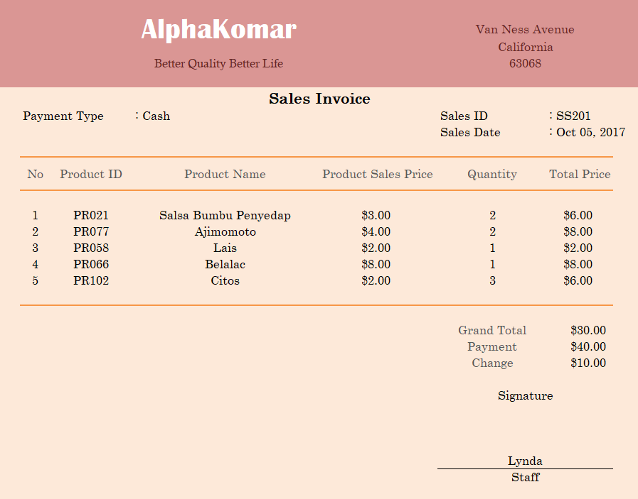

**Figure 1. Sales Invoice**

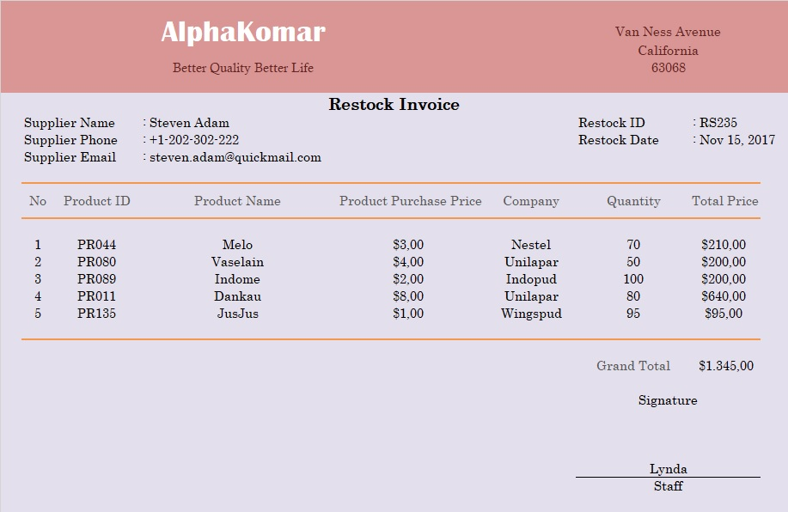

**Figure 2. Restock Invoice**

**Based on those two invoices above,**

1. **Make normalization for Sales Invoice! (UNF, 1NF, 2NF, 3NF)**
2. **Make normalization for Restock Invoice! (UNF, 1NF, 2NF, 3NF)**

Additional information:

1. Employee’s data must include some information below:
   1. Employee ID
   2. Employee E-mail
   3. Employee DOB
   4. Employee Address
2. Products’ data must include some information below:
   1. Product Description
   2. Product Stock
3. Supplier’s data must include some information below:
   1. Supplier ID
   2. Supplier Address
4. Company’s data must include some information below:
   1. Company ID
   2. Company Address

**Attention!**

ANY ADDITIONAL INFORMATION WHICH IS NOT STATED IN THE CASE ABOVE WILL REDUCE YOUR SCORE.